Ayonna Jones

Professor Michael Spivey

COGS 104

10 February 2020

Assignment 2: Playing with Probablilty

Part A) Demonstrate the Gambler’s Falicy

It is commonly believed that a long series of identical results in a game of chance is highly likely to be followed by a non-identical result. For example, if a fair coin flips Heads 4 times in a row, then a Tails is more than 50% likely on the next flip. Not true. Prove it to yourself by flipping a coin 10,000 times, and finding every instance of 4-head-in-a-row and count how many Heads and how many Tails happen on the subsequent flip.

clear

ff=[];

flip=round(rand(1,10000));

for n=4:9999

if flip(n-3:n)==[1 1 1 1];

ff=[ff flip(n+1)];

end

end

mean(ff)

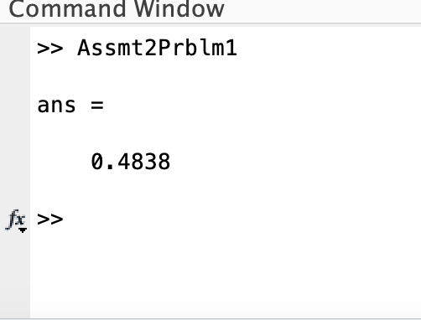

Part B) Prove d’Alembert wrong

The French mathematician d’Alembert famously argued that in a pair of coin flips, two-heads-in-a-row has a 1/3 probability rather than the more commonly believed 1/4 probability, because if your first flip is a tails, then you wouldn’t keep flipping. So, with only three possible results [a) flip tails then stop, b) flip heads then flip tails, c) flip heads then flip heads], each result has a 1-in-3 probability. Makes sense, doesn’t it? Prove him wrong.

clear

hh=0;

for n=1:10000

flip1=round(rand);

if flip1==1

flip2=round(rand); %flipped coin

if flip2==1

hh=hh+1 %increase hh by 1

end

end

end

mean(hh)\*.0001

